RippleWealth – AI-Driven Investment Risk Intelligence Platform
Sharvani Kadarla^{#1}, Deepali Sawant^{*2}, Jai Sheel Bhasker Paladugu^{#3}, Ashish Reddy Majjigapu^{#4}
#Department of Computer Science, Pace University
New York, USA
¹sk10362n@pace.edu
²ds83110n@pace.edu
³jp03982n@pace.edu
⁴am37448n@pace.edu

Abstract— Modern investment platforms are largely reactive, alerting investors only after stock prices have already shifted. RippleWealth is an AI-driven investment risk intelligence platform designed to move beyond reactive price-based analysis by detecting early real-world signals—such as weather events, supply chain disruptions, and labor strikes—before they manifest in financial markets. Utilizing a multi-agent AI architecture and Large Language Model (LLM)–based causal reasoning, the platform maps disruption propagation across industries to provide proactive, explainable risk insights. This study details the system's architecture, including its integration of geospatial infrastructure data and natural language advisory agents.

Keywords— AI-driven finance, risk intelligence, causal reasoning, knowledge graphs, investment management.

- INTRODUCTION
The modern investment landscape is characterized by high volatility and an overwhelming influx of real-time information. However, traditional investment platforms remain largely reactive, typically alerting investors only after significant stock price movements have occurred. This technological lag exists because current tools focus almost exclusively on lagging financial indicators while ignoring early, non-financial risk triggers such as supply chain disruptions, extreme weather events, labor strikes, and logistics delays. Consequently, both retail and professional investors lack the proactive insights and clear causal explanations necessary to anticipate risk before it manifests in asset prices.

The current study focuses on the development of RippleWealth, an AI-driven investment risk intelligence platform designed to move beyond traditional price-based analysis. Unlike standard tools, this work utilizes a multi-agent AI architecture and Large Language Model (LLM) causal reasoning to detect "Butterfly Events"—small-scale real-world disruptions—and trace their propagation pathways across global industries and specific company holdings. By integrating interactive Knowledge Graphs and explainable risk metrics such as Value-at-Risk (VaR), this effort seeks to advance understanding of systemic risk propagation. The relevance of this work lies in its ability to empower investors with transparent, data-driven narratives, transforming risk management from a reactive necessity into a proactive strategic advantage.

- LITERATURE REVIEW
The evolution of investment risk management has transitioned from basic statistical models to complex, data-driven systems. Historically, the assessment of market risk relied almost exclusively on lagging financial indicators and historical price volatility. While these traditional tools are effective at reporting what has already occurred, they are inherently reactive and fail to account for early, real-world signals.

A. Reactive vs. Proactive Risk Intelligence

Modern investment platforms typically alert investors only after stock prices have already shifted. This creates a significant information gap, as the primary drivers of market shifts—such as supply chain disruptions, extreme weather, and labor strikes—often occur days or weeks before they are reflected in financial data. The study explores moving beyond this reactive analysis by detecting "Butterfly Events" as they happen to provide early insights into potential portfolio impacts.

B. Causal Reasoning and Knowledge Graphs

Existing financial tools often suffer from a "black-box" problem where users cannot see the underlying cause-and-effect of why portfolio risk is increasing. Research in quantitative finance has recently begun to explore graph-based models to map systemic risk pathways. This work advances the field by using Large Language Model (LLM) reasoning and multi-agent AI to simulate second- and third-order domino effects. Unlike manual scenario modeling, which is time-consuming and often lacks integrated causal analysis, this study utilizes Neo4j to visualize direct and indirect impact paths through an interactive Knowledge Graph.

C. Alternative Data and Infrastructure Risk

The integration of alternative data—such as logistics reports, weather feeds, and labor news—is critical for accurate risk forecasting. This research further distinguishes itself by incorporating regional infrastructure data, specifically broadband and geospatial connectivity metrics. By comparing global events with specific regional vulnerabilities stored in SQL databases, the study provides a more granular risk assessment than platforms that rely solely on macroeconomic indicators. This shift toward explainable, signal-based intelligence ensures that risk metrics like Value-at-Risk (VaR) are grounded in real-world causality rather than historical probability alone.

- PROJECT REQUIREMENTS
Mentioned below are the product requirements for making sure the work runs at optimal performance and fulfills its defined functional requirements.

- Software Requirements
- Backend Framework: FastAPI (Python) for building high-performance RESTful APIs, managing user authentication, and coordinating risk calculations.
- Frontend Framework: React (Vite) for the interactive dashboard and Knowledge Graph visualizations.
- Database Management: A hybrid approach using PostgreSQL (via SQLAlchemy) for relational data and Neo4j for causal impact graphs.
- AI & Analytics: Python-based libraries for Monte Carlo simulations, keyword NLP, and LLM reasoning logic.
B. Hardware Requirements
- Development: Windows PC or Apple MacBook with sufficient memory to run local API servers and graph database containers.
- End User: Any internet-enabled desktop or mobile device (iOS/Android).
C. Functional Requirements
- User Access: The system must include secure registration and login features.
- Portfolio Analysis: Users must be able to view, upload, and update asset holdings.
- Risk Metrics: The system must display portfolio risk metrics, including Value at Risk (VaR) and sector exposure.
- Event Simulation: Users can run simulations to understand the potential impact of global events on portfolio value.
D. Technical Requirements
- API Architecture: The system uses FastAPI to expose REST APIs for portfolio data and AI-based recommendations.
- Data Ingestion: Automated pipelines fetch "Butterfly Events" from news, weather, and geospatial infrastructure databases.

- SYSTEM DIAGRAM
The RippleWealth architecture is designed as a modular, event-driven framework capable of transforming unstructured global news into actionable financial intelligence. The system's structural integrity and logic flow are documented through five primary modeling perspectives.

A. System Architecture Diagram

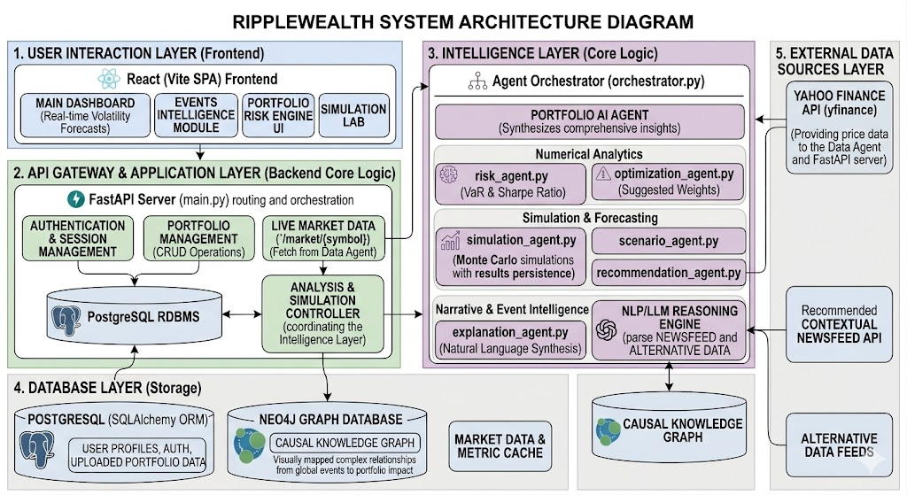
Figure 4.1 System Architecture Diagram

The System Architecture illustrates a decoupled, five-tier stack designed for scalability and polyglot persistence.

- User Interaction Layer (Frontend): A React-based Single Page Application (SPA) optimized with Vite for high-performance rendering of real-time volatility forecasts, interactive causal maps, and a dedicated Simulation Lab.
- API Gateway & Application Layer (Backend): Centered on a FastAPI server, this layer manages RESTful routing, session authentication, and serves as the primary controller orchestrating the intelligence agents.
- Intelligence Layer (Core Logic): The system's "brain," where an Agent Orchestrator manages specialized units. This includes Numerical Analytics (Value-at-Risk and Sharpe Ratio), Simulation units (Monte Carlo engines), and Narrative Intelligence (NLP/LLM reasoning for natural language synthesis).
- Database Layer (Polyglot Storage): Employs a hybrid strategy using PostgreSQL (via SQLAlchemy ORM) for structured relational data—such as user profiles and asset holdings—and Neo4j for a Causal Knowledge Graph, visually mapping non-linear event propagation.
- External Data Sources Layer: Integrates asynchronous ingestion from the Yahoo Finance API (yfinance), Contextual Newsfeeds, and Alternative Data feeds (Geospatial/Infrastructure status).

B. Context Diagram

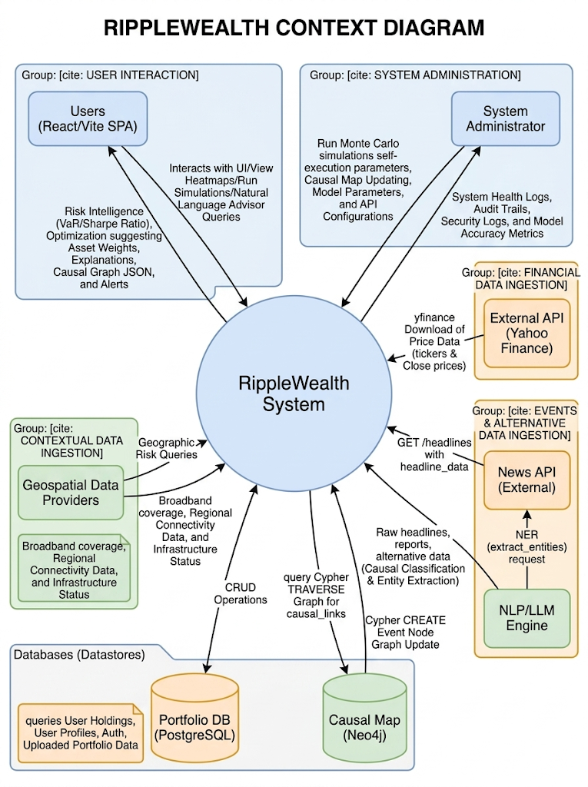
Figure 4.2 Context Diagram

The Context Diagram defines the operational boundaries of RippleWealth and its bidirectional data exchange with external actors.

- Investors: Primary stakeholders who provide portfolio data and Natural Language Queries, receiving explainable risk intelligence and proactive hedge suggestions.
- External Providers: The system maintains high-frequency connections to Financial APIs for market metrics and News Providers for raw headlines and reports for NLP classification.
- Geospatial Data Providers: Supply critical infrastructure stability metrics used to assess regional "Butterfly Event" severity.
- System Administration: A back-end actor responsible for monitoring model accuracy metrics, audit trails, and system health logs to ensure the reliability of the AI reasoning engine.

C. Sequence Diagram

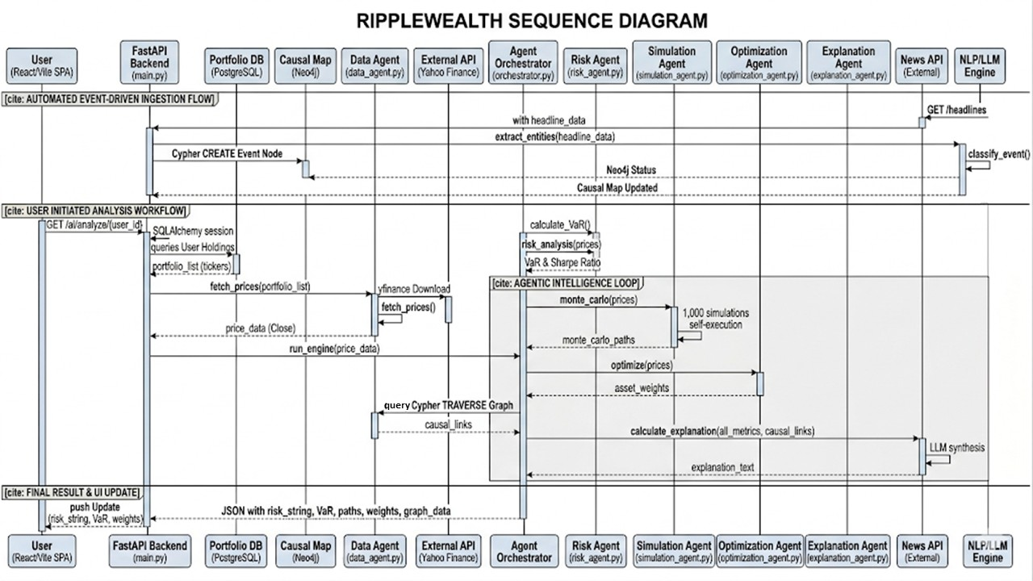
Figure 4.3 Sequence Diagram

The Sequence Diagram captures the temporal flow of an analysis request, highlighting the agentic intelligence loop.

- Automated Ingestion: The flow is triggered by a News API headline fetch, followed by entity extraction and causal classification within the NLP/LLM engine.
- User-Initiated Analysis: Upon a client request, the FastAPI backend fetches user holdings from PostgreSQL and real-time prices via the Data Agent.
- Agentic Loop: The Agent Orchestrator triggers a parallel execution path where the Risk Agent calculates metrics, the Simulation Agent runs 1,000+ Monte Carlo paths, and the Optimization Agent suggests asset weights.
- Final Synthesis: The Orchestrator queries the Neo4j Causal Map to link these metrics to global events, producing a consolidated JSON payload for the dashboard update.

D. State Diagram

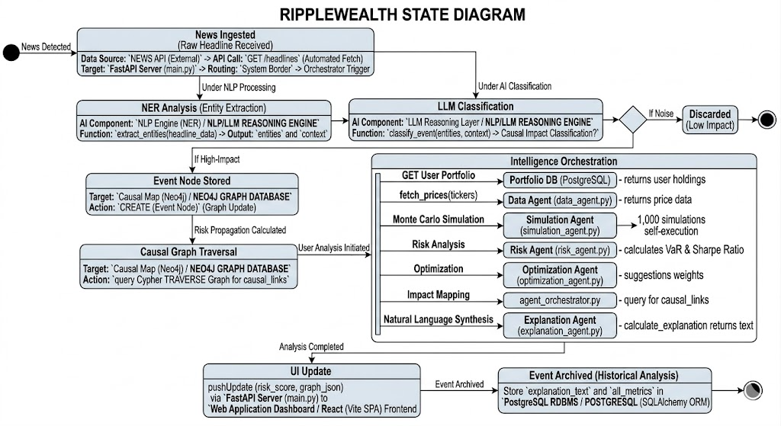
Figure 4.4 State Diagram

The State Diagram models the lifecycle of a detected disruption from raw signal to historical archive.

- Detection & NER: Raw headlines transition from "News Detected" to an "Entity Extraction" state.
- Heuristic Decision Node: Events are evaluated against a "Noise" threshold; low-impact signals are discarded, while high-impact "Butterfly Events" trigger a Graph Update in Neo4j.
- Causal Traversal & Simulation: The system enters a state of deep propagation analysis, mapping the industry-to-company impact.
- Archival: Following a successful UI update, the event and its associated LLM-generated explanation are archived in PostgreSQL for historical regression analysis.

E. Database Schema Diagram

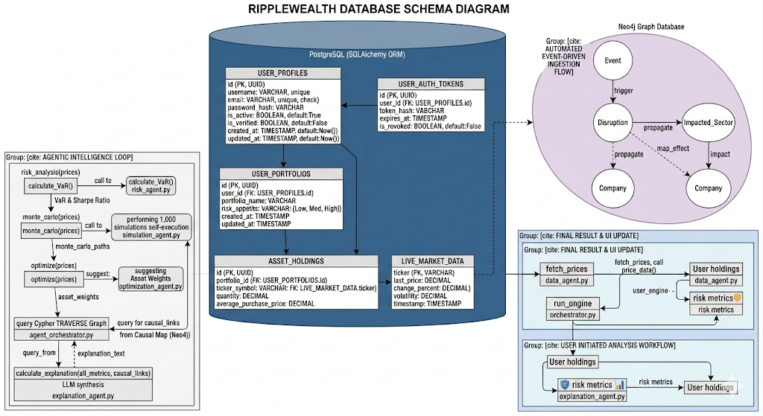
Figure 4.5 Database Schema Diagram

The Database Schema details the hybrid storage strategy utilized to support structured management and complex causal analysis.

- Relational Schema (PostgreSQL): Manages structural integrity, including User Profiles, Auth Tokens, User Portfolios, and Asset Holdings. It includes a Live Market Data table that acts as a synchronized cache for the latest pricing and volatility metrics.
- Causal Knowledge Graph (Neo4j): Unlike static relational tables, the graph schema is optimized for traversal. It defines relationships between Events, Disruptions, and Impacted Sectors.
- Data Integration: The schema illustrates how the Agent Orchestrator pulls structured portfolio data from SQL while simultaneously executing Cypher queries on Neo4j to map those holdings against the current causal risk landscape.

- API DOCUMENTATION
The RippleWealth system exposes a set of RESTful endpoints implemented using the FastAPI library and can be accessed using HTTP GET and POST requests. These endpoints enable interaction between the frontend interface and backend modules responsible for portfolio analysis, event tracking, risk computation, simulation, and recommendation generation.

- The /events endpoint returns a list of global events with attributes including title, affected industry, severity level, and confidence score.
- The /portfolio endpoint returns a list of assets, including their associated tickers and investment values.
- The /portfolio/risk endpoint provides computed metrics such as Value at Risk (VaR), Conditional Value at Risk (CVaR), and sector exposure distribution.
- The /recommend endpoint accepts an event as input and generates investment recommendations.
- The /simulate endpoint accepts a JSON object containing a selected event and computes a projected portfolio value over a series of time steps.
- The /rebalance endpoint provides a recommended portfolio reallocation strategy by comparing the current portfolio with an optimized allocation and explaining the rationale behind the adjustments.
- The /graph endpoint returns a structured representation of relationships between events, industries, assets, and the portfolio in the form of nodes and edges.

- CONCLUSION
In conclusion, RippleWealth delivers a comprehensive solution for event-driven portfolio risk analysis and investment decision support. By integrating risk assessment, simulation, and recommendation capabilities, the platform enables users to understand and respond to market disruptions effectively.
The system demonstrates the practical application of modern web technologies and analytical methods in financial decision-making. Its architecture supports continuous enhancement, including integration with real-time data, predictive modeling, and intelligent advisory systems.
Overall, RippleWealth enhances portfolio management by providing actionable insights and enabling proactive risk mitigation in dynamic market environments.

VII. SUMMARY
RippleWealth is an event-driven portfolio intelligence platform that analyzes how global disruptions impact financial markets and investment portfolios. The system integrates a FastAPI backend with a React frontend to deliver a responsive and interactive user experience.
The platform follows a structured workflow consisting of event detection, industry impact mapping, portfolio exposure evaluation, simulation, and recommendation generation. It enables users to visualize portfolio holdings, assess risk using VaR and CVaR metrics, simulate potential outcomes, and receive data-driven investment suggestions.
A knowledge graph component models causal relationships among events, industries, and assets, thereby improving transparency and interpretability. The system is designed with a modular architecture, enabling scalability and integration with advanced analytics and real-time data sources.

VIII. REFERENCES
[1] G. Yu, X. Wang, Q. Li, and Y. Zhao, “Fusing LLMs and KGs for Formal Causal Reasoning behind Financial Risk Contagion,” arXiv preprint arXiv:2407.17190, 2024.
[2] C. Lee, Y. Jeong, J. Shin, H. Kim, and J. Kim, “Knowledge Graph Construction for Stock Markets with LLM-Based Explainable Reasoning,” in Proc. 34th ACM Int. Conf. on Information and Knowledge Management (CIKM ’25), Seoul, Republic of Korea, 2025.
[3] U. Jaimini and A. Sheth, “CausalKG: Causal Knowledge Graph Explainability using Interventional and Counterfactual Reasoning,” arXiv preprint arXiv:2201.03647, 2022.
[4] Anonymous, “Large Language Model Enhanced Clustering for News Event Detection,” arXiv preprint arXiv:2406.10552, 2024.

